## **Step 1: Update the system**

Updating your system before installing anything is considered a good practice, therefore, you can use the following command to perform this action.

*$* sudo apt update && sudo apt upgrade -y

**Output  
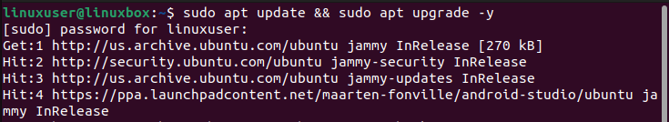**

The system has been updated and upgraded.

[How to Install and Use Build Essential Tools on Ubuntu 22.04](https://linuxhint.com/install-use-build-essential-tools-ubuntu/)

[How To Install Zlib on Ubuntu 22.04](https://linuxhint.com/install-zlib-ubuntu-22-04/)

[How to Install Sublime Text 4 in Ubuntu 22.04 LTS](https://linuxhint.com/install-sublime-text-3-on-ubuntu/)

[How to install Liferea on Ubuntu](https://linuxhint.com/install-liferea-ubuntu/)

[How to download and install Visual Novel Engine Ren'Py on Raspberry Pi](https://linuxhint.com/download-install-visual-novel-engine-renpy-raspberry-pi/)

[How to Install Bitcoin Core in Ubuntu 22.04](https://linuxhint.com/https-linuxhint-com-install-bitcoin-core-ubuntu/)

[How to Install Code Blocks on Linux Mint 21](https://linuxhint.com/install-code-blocks-linux-mint/)

[How to install Eclipse IDE on Ubuntu](https://linuxhint.com/install-eclipse-ide-ubuntu/)

[How to Install CopyQ in Ubuntu 20.04](https://linuxhint.com/install-copyq-ubuntu/)

[How to Install & Use KIO GDrive in Ubuntu 20.04](https://linuxhint.com/install_use_kio_gdrive_ubuntu/)

[How to Install and Use Restic on Ubuntu](https://linuxhint.com/how-to-install-and-use-restic-on-ubuntu/)

[Install Wavebox in Ubuntu 20.04](https://linuxhint.com/wavebox-email-client-gmail-outlook-office-365/)

[How to Set Up SSH Keys on Ubuntu 22.04](https://linuxhint.com/set-up-ssh-keys-on-ubuntu-22-04/)

[How to Install Ambient Light Software Hyperion on Raspberry Pi](https://linuxhint.com/install-hyperion-raspberry-pi/)

[How to Use APT Package Manager in Ubuntu 22.04](https://linuxhint.com/apt-package-manager-ubuntu/)

[How to Install Fail2Ban on Raspberry Pi](https://linuxhint.com/install-fail2ban-on-raspberry-pi/)

[How to Install OBS on Linux Mint 21](https://linuxhint.com/install-obs-linux-mint-21/)

[How to Install LibreOffice on Linux Mint 21](https://linuxhint.com/install-libreoffice-linux-mint-21/)

[How to Install FFmpeg on Linux Mint 21](https://linuxhint.com/install-ffmpeg-linux-mint-21/)

[How to Install Matplotlib on Raspberry Pi](https://linuxhint.com/install-matplotlib-raspberry-pi/)

[How to Start Service on Boot on Ubuntu 22.04](https://linuxhint.com/start-service-boot-ubuntu/)

[How to Install and Configure the SmartGit Client on Linux](https://linuxhint.com/smartgit-git-clients-linux/)

[How to Setup Open VPN in Ubuntu 22.04](https://linuxhint.com/setup-openvpn-ubuntu-22-04/)

[How to Install qTox Messenger on Raspberry Pi](https://linuxhint.com/install-qtox-messenger-raspberry-pi/)

[How to Install Penpot Figma Alternative on Raspberry Pi](https://linuxhint.com/install-penpot-figma-alternative-on-raspberry-pi/)

## **Step 2: Install packages**

Now once the system is updated there are certain packages that need to be installed on your system before you install the editor.

*$* sudo apt install software-properties-common apt-transport-https wget -y

**Output  
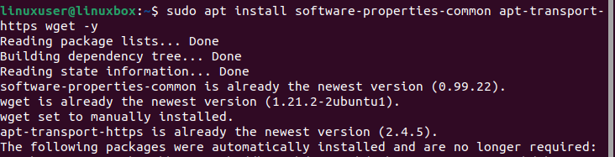**

## **Step 3: Import repository**

After installing the packages, the next step is to include the Visual Studio Code repository but before that Microsoft GPG key needs to be imported to authenticate the packages installed.

*$* wget -O- https://packages.microsoft.com/keys/microsoft.asc | sudo gpg --dearmor | sudo tee /usr/share/keyrings/vscode.gpg

**Output  
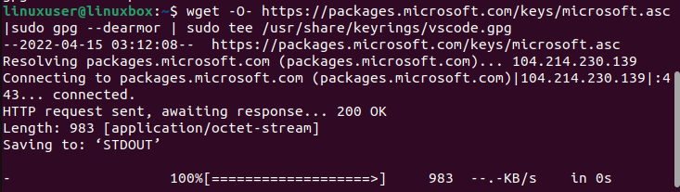**

This will validate the originality of the packages installed. Now let’s move towards including the Microsoft Visual Source repository.

*$* echo deb [arch=amd64 signed-by=/usr/share/keyrings/vscode.gpg] https://packages.microsoft.com/repos/vscode stable main | sudo tee /etc/apt/sources.list.d/vscode.list

**Output  
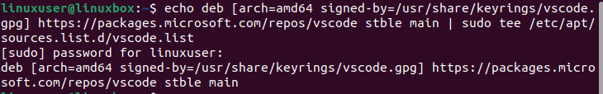**

## **Step 4: Update the system again**

After installing the packages, and importing the repository, updating your operating system is recommended.

*$* sudo apt update

**Output  
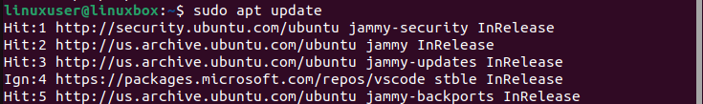**

System updated successfully.

## **Step 5: Install the editor**

Now simply run the below-given command on the terminal to install Visual Studio Code Editor.

*$* sudo apt install code

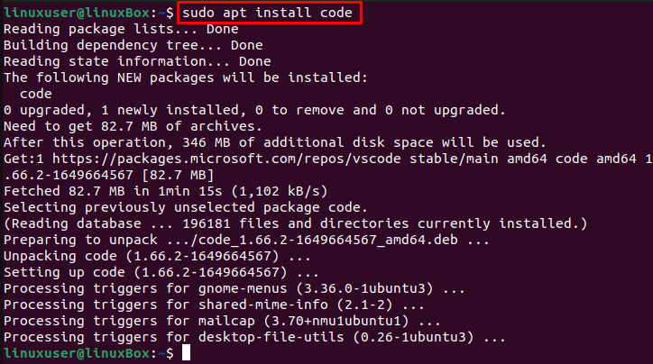

The Visual Studio code is successfully installed on Ubuntu 22.04.

## **How to Launch the app**

Run this command to start the application.

*$* code

**Or,**

*$* code &

Apart from this, to launch VS code on Ubuntu, open the Application menu and search for code:

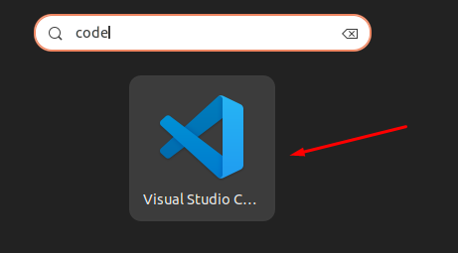

Now click on the icon to launch the app.

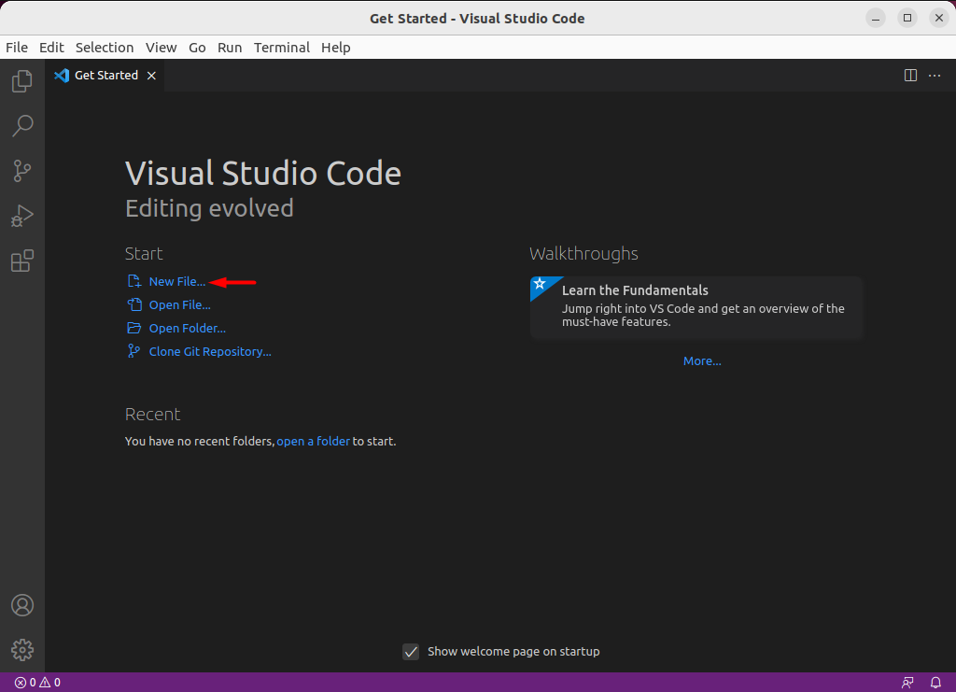

You can now open the new file and start writing your code.

## **Installing Visual Studio Code through Snap store**

To install Visual Studio code through Snap store on Ubuntu, simply execute the command:

*$* sudo snap install code

**Output**



The editor has been installed successfully.

Snap is already installed on Ubuntu 22.04 by default. However, if you do not have snap due to any reason, you can install it using the command given below: